**Project Overview**

Pianos are large instruments that cannot be carried everywhere. Even electric pianos need to be carried in a large bag and are prone to damage in travelling. So here we propose a portable virtual piano that just uses semi-transparent plastic sheet that can be carried and does not have any electronic components in it. We use a raspberry pi attached to a camera along with the plastic sheet to make a virtual piano. We use image processing to divide the plastic sheet into sections and assign particular tomes to it. We the detect human fingers through the plastic sheet and simulate associate piano tone for each section to play piano tones using a speaker. Thus, we provide a virtual piano which is actually a transparent light weight plastic board that can be carried around roughly.

**Objectives**

* Assigning the respective tones of piano to the corresponding segments of Virtual Piano made using semi-transparent plastic sheet.
* Real time motion detection of fingers using a camera linked with Raspberry pi.
* To play the tone assigned to a segment on detection of finger on that particular segment.

**Methodology**

Pianos are large instruments that cannot be carried everywhere. Even electric pianos need to be carried in a large bag and are prone to damage in travelling. So here we propose a portable virtual piano that just uses semi-transparent plastic sheet that can be carried and does not have any electronic components in it. We use a raspberry pi attached to a camera along with the plastic sheet to make a virtual piano. We use image processing to divide the plastic sheet into sections and assign particular tomes to it. We the detect human fingers through the plastic sheet and simulate associate piano tone for each section to play piano tones using a speaker. Thus, we provide a virtual piano which is actually a transparent light weight plastic board that can be carried around roughly. We propose a method for identifying a piano keyboard present in the video footage of a standard webcam with the goal of teaching chords, scales and suggested finger positions to a beginner pianist. Our keyboard identification method makes use of binary thresholding, Sobel operators and Hough transforms, as well as proposed algorithms specific to this application, to first find an area resembling a piano keyboard before narrowing the search to detect individual keys. Through the use of our method the keys of a piano keyboard were successfully identified from webcam video footage, with a tolerance to camera movement and occluded keys demonstrated. This result allowed the augmented reality style highlighting of individual keys, and the display of suggested fingering, for various chords and scales.

**Project Outcomes**

* Virtual Pianos will reduce the problem of carrying large sized pianos.
* Large Pianos are prone to damage in travelling and these Virtual Pianos will take care of this issue.
* Virtual Pianos will be much cheaper than traditional pianos.
* It will help young children to get a feel for music and will act as a stepping stone for some of the world’s greatest artists.

**Work Plan**

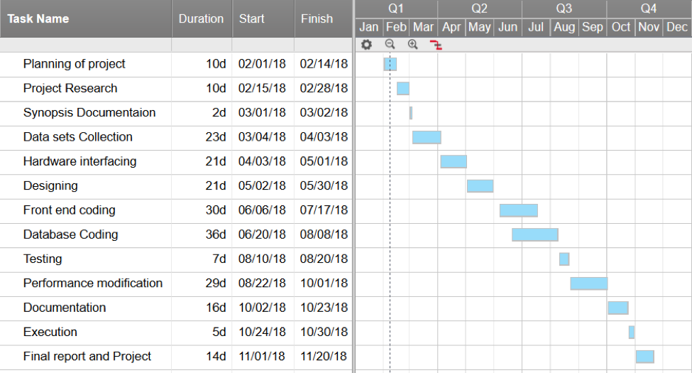

**References**

[1] E. Dawe and R. Green, "Computer Vision Piano Tutor," Canterbury University 2010.

[2] C. Deaker and R. Green, "A Computer Vision Method of Piano Tutoring, Without the Piano," Canterbury University 2011.

[3] F. Huang, Y. Zhou, Y. Yu, Z. Wang, and S. Du, "Piano AR: A Markerless Augmented Reality Based Piano Teaching System," in Intelligent Human-Machine Systems and Cybernetics (IHMSC), 2011 International Conference on, 2011, pp. 47-52.

[4] D. O. Gorodnichy and A. Yogeswaran, "Detection and tracking of pianist hands and fingers," in Computer and Robot Vision, 2006. The 3rd Canadian Conference on, 2006, pp. 63-63.

[5] A. Oka and M. Hashimoto, "Marker-less piano fingering recognition using sequential depth images," in Frontiers of Computer Vision, (FCV), 2013 19th Korea-Japan Joint Workshop on, 2013, pp. 1-4.

[6] C.-H. Yeh, W.-Y. Tseng, J.-C. Bai, R.-N. Yeh, S.-C. Wang, and P.-Y. Sung, "Virtual Piano Design via Single-View Video Based on Multifinger Actions Recognition," in Human-Centric Computing (HumanCom), 2010 3rd International Conference on, 2010, pp. 1-5.

[7] K. Huang, E. Y. L. Do, and T. Starner, "PianoTouch: A wearable haptic piano instruction system for passive learning of piano skills," in Wearable Computers, 2008. ISWC 2008. 12th IEEE International Symposium on, 2008, pp. 41-44.

[8] M. Lang and R. Green, "Musical Desktop: A Webcam Piano," Canterbury University 2012.

[9] C.-C. Lin and D. S.-M. Liu, "An intelligent virtual piano tutor," presented at the Proceedings of the 2006 ACM international conference on Virtual reality continuum and its applications, Hong Kong, China, 2006.

[10] M. Sotirios and P. Georgios, "Computer vision method for pianist's fingers information retrieval," presented at the Proceedings of the 10th International Conference on Information Integration and Web-based Applications & Services, Linz, Austria, 2008.

[11] J. Savard. (N.D., 04/05/2013). The Size of the Piano Keyboard [Online]. Available: http://www.quadibloc.com/other/cnv05.htm

[12] B. Kraemer. (N.D.). Major Piano Triad Chords [Online]. Available: http://piano.about.com/od/chordskeys/ss/major_triads_treble.htm

[13] R. Kelley. (2001, 04/05/2013). Scale Fingering Chart [Online]. Available: http://www.robertkelleyphd.com/scalfing.htm

[14] N. Wickham. (2010, 04/05/2013). Free Piano Scale Fingering Diagrams [Online]. Available: http://musicmattersblog.com/2010/04/06/free-pianoscale-fingering-diagrams/